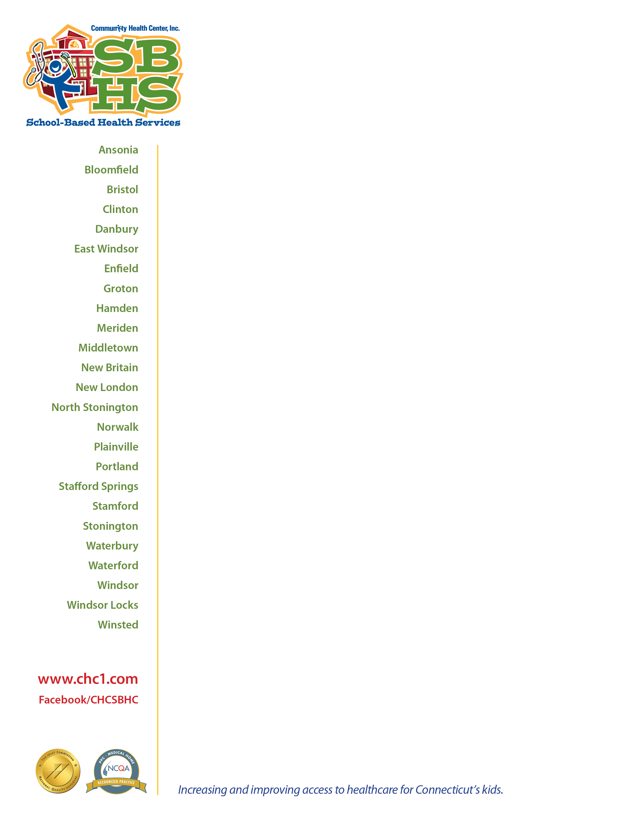

August 31, 2023

Dear Parents and Guardians,

Community Health Center, Inc. (CHCI) is pleased to have a School-Based Health Center (SBHC) at your child’s school. We are reaching out to families who have enrolled and consented for their child to receive medical, dental and/or behavioral health care at the SBHC to share important information.

CHCI has been providing health care in Connecticut for more than 50 years, including through SBHCs for the last 25 years. Our goal is to ensure access to health care, regardless of ability to pay, in as convenient a location as possible.

Our Sliding Fee Scale Discount Program (SFSDP) is available to assist all eligible patients to reduce visit fees based on income and family size. This includes anyone with or without insurance. We will work with you to see if you qualify for this program.

If you have health insurance, we will continue to bill services to your insurance. Beginning October 1, 2023, you may begin to see billing statements from CHCI for any deductible or co-pay responsibilities determined by your plan. Applying for the Sliding Fee Scale Discount Program could result in reductions to your out-of-pocket costs. If you are unable to pay for these services, or do not qualify for the discount program, please reach out to us. We will not deny care based on your inability to pay; our goal is to make sure you have access to the care and services your child needs. For more information about our SFSDP application, or other payment options available, visit our website at CHC1.co/payment.

Our staff is available to answer questions and provide assistance:

* To speak to one of our team members about your bill, contact our billing department at 888-270-6698.
* To apply for our SFSDP, text “SFS” to 860-560-1398 and a member of our Access to Care team will assist you, or you may call CHCI’s main line 860-347-6971, extension 4155, to reach a team member.

Sincerely,

Your CHCI School-Based Care Team